**Introduction to HTML – Lesson 1**

**Task 1:**

Choose a personal interest (hobby, subject at school etc) which you can use as the main topic of your very first ‘self-coded’ webpage.

Write your topic here:

|  |
| --- |
|  |

**Task2:**

* 1. Open Notepad and type in the following: (note the indentations)  
       
     <HTML>

<HEAD>

<TITLE>Your Website Title here</TITLE>

</HEAD>

<BODY>

</BODY>

</HTML>

Save your file as a HTML in your HTML folder (create one if you have not already) file by:

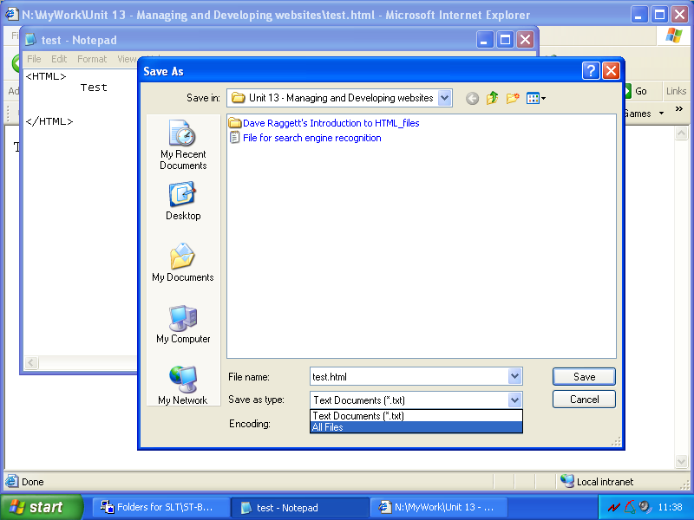

Ensure you change the type to “All Files” (not a txt file)

Give your file a name followed by a “.” and add the extension “html”

View your file on the browser by opening your newly created file using the File option in Internet Explorer or by simply double clicking on the html file when view in Explorer.

**Task 3:**

1. Go back to notpad and now let’s add a ‘Heading’ onto our page.
2. Remember that if we want text to appear on the page it must be added between the <body> tags…so add a page heading here!

Example:

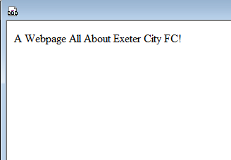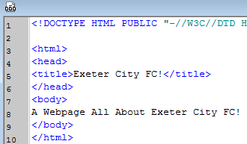

1. It doesn’t look much like a heading, so let’s format the text to make it bigger. For this we need to surround the text with heading tags <h1></h1>.

Example:

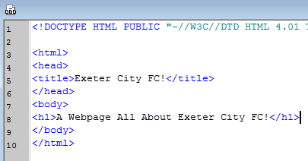



1. Try changing the number in the tags – see what happens to the size!

**Task 4:**

1. Now let’s add a horizontal rule to try to separate our heading from the main part of the page.
2. To do this we use the horizontal rule tag **<hr>**

Example:

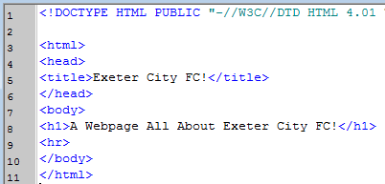



**Task 5:**

1. Now let’s add some text onto our page.
2. To add text we place each line of text between paragraph tags: **<p>***your text goes here***</p>**



Example:

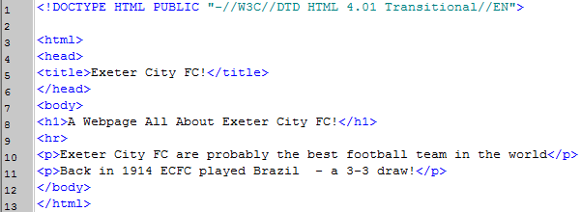

**Task 6 (Extension 1):**

1. Use the glossary below and try to add an image onto your page.
2. You will need to save the image file in the same location as this HTML file you are writing.

**Task 7 (Extension 2):**

1. Use the internet to research how to add a background colour to your page.
2. A good source of information is <http://www.w3schools.com/>

**Task 8 (Extension 3):**

1. Develop your page with more information and images and try to use the various formatting tags to better position these page items on the webpage. Again, use the internet to find out about more formatting tags.

**HTML Tags – Lesson 1 Glossary**

